

Clock Spring evaluation in crack assessments in spiral pipeline: failure assessment diagrams with variations in crack characteristics



# Introduction

Investigation of cracks and crack growth is a crucial part of the analysis in pipeline industry. In accordance with today’s need for sustainable development, a more accurate assessment for safe cracks is of concern since it could significantly extend equipment life while improving system reliability. By increasing the tolerance interval for flaws and fatigue damage, the need for service and new material is decreased. In this way, both financial and material resources are saved.

Even though, implementing conventional FEM is accurate in evaluating fracture mechanics, it has some limitations regarding the modeled geometry and the mesh has to match the crack geometry. So, Applying the extended finite element method (XFEM) could pave the way to avoid these obstacles. references where the XFEM has been successfully employed for discontinuities are found e.g. in [1, 2, 3, 4].

The primary goal of this report is to know the failure criteria of the modeled pipe using the XFEM in Abaqus and to evaluate the possibilities to analyze critical crack sizes under various loads. besides, to evaluate how could Clock Spring composite sleeves reinforce applied critical stresses.

A linear elastic material model has been used throughout the crack simulations. Hence, the work has only been carried out considering linear elastic fracture mechanics (LEFM). This follows from the fact that Abaqus only allows for elastic material models in XFEM simulations.

The analysis has been performed with stationary pre-existing cracks, due to the complexity and calculation extent of growing cracks. The work has been devoted to an evaluation of stationary crack simulations in XFEM. And the reliability of Clock Spring composite sleeves, enabling a strategy proposal for improved crack assessment. Focus has consequently been upon the ability to estimate critical flaw size under design loads, meaning that the stress intensity factor (SIF) for a certain crack can be anticipated.

# Governing Equations

The extended finite element method (XFEM) is a numerical method that permits a local enhancement of approximation spaces. The method is useful for the approximation of solutions with definite characteristics in small parts of the computational domain, for example near discontinuities and singularities. In these cases, standard numerical methods such as the FEM often exhibit poor accuracy. The XFEM offers significant advantages by enabling optimal convergence rates for these applications.

The description of discontinuities in the context of the XFEM is often realized by the level-set method. A level-set function is a scalar function within the domain whose zero-level is interpreted as the discontinuity. As a consequence, the domain Ω is devided into two subdomains and Ω− on either side of the discontinuity where the level-set function is positive or Ω+ negative, respectively. All equations will be calculated based on ref. [5] which is presented as below.

For example, consider a two-dimensional domain with a circular discontinuity of radius (0,0), see Fig. 1. Then, this discontinuity may be defined by the level-set function

|  |  |
| --- | --- |
| ϕ(x. y) = √x2 + y2 − r | (1) |

which is zero on the circle.

|  |
| --- |
| http://www.xfem.rwth-aachen.de/Background/Introduction/Figures/Fig3.png |
| Fig. 1. A circular discontinuity model [5] |

Often, the signed distance function is used as a particular level-set function

|  |  |
| --- | --- |
| ϕ(x) = ± min||x − xΓ|| | (2) |

where the sign is different on the two sides of the discontinuity and || || denotes the Euclidean norm,

|  |  |
| --- | --- |
| ||z|| = √z2 + z2 + ⋯ + z2  1 2 n | (3) |

It is noted, that level-set functions are typically defined by discrete values at the nodes ϕi = ϕ(xi) in the domain. They are then interpolated in the element interiors by standard finite element shape functions,

|  |  |
| --- | --- |
| ϕh(x) = ∑Ni(x) ∙ ϕi | (4) |

To know the basic of the XFEM consider an n-dimensional domain Ω ∈ ℝn which is discretized by nelelements, made from 1 tonel. I is the set of all nodes in the domain, and Iel are the nodes of element k ∈ {1 … . nel} . A standard extended finite element approximation of a function u(x) is of the form

k

|  |  |
| --- | --- |
| uh(x) = ∑Ni(x)ui + ∑Mi(x)ai | (5) |

The first term depicts standard FE approximation and second term revealed enrichment where for simplicity only one enrichment term is considered. The approximation consists of a standard finite element (FE) part and the enrichment. The individual variables stand for:

uh(x): approximated function

ui: unknown of the standard FE part at node i Ni(x): standard FE function of node i

I: set of all nodes in the domain

Mi(x): local enrichment function of node i ai: unknown of the enrichment at node i I∗: nodal subset of the enrichment

The enrichment is built by local enrichment functions Mi(x) and unknowns ai which

are defined at nodes in I∗ ⊂ I . The local enrichment functions have the form

|  |  |
| --- | --- |
| Mi(x) = N∗(x) ⋅ ψ(x)  i | (6) |

and we call N∗(x) partition of unity functions and ψ(x) global enrichment function. The functions N∗(x) are standard FE shape functions which are not necessarily the same than those of the standard part of the approximation ([5](http://www.xfem.rwth-aachen.de/Background/Introduction/XFEM_Introduction.php#eq%3AXFEMApprox)). These functions build a partition of unity,

i

i

|  |  |
| --- | --- |
| ∑Ni(x)ui = 1 | (7) |

in elements whose nodes are all in the nodal subset I∗, see Fig. 2. In these elements, the global enrichment function ψ(x) can be reproduced exactly; we call these elements reproducing elements. In elements with only some of their nodes

in I∗, N∗(x) does not build a partition of unity, ∑N∗(x) ≠ 1, see Fig. 2. As a

i i

consequence, the global enrichment function ψ(x) cannot be represented exactly in these elements. Elements with only some of their nodes in I∗ are called blending elements. Several publications discuss problems arising from blending elements.

|  |
| --- |
| http://www.xfem.rwth-aachen.de/Background/Introduction/Figures/Fig4.png |
| Fig. 2. Element presentation [5] |

Equation ([5](http://www.xfem.rwth-aachen.de/Background/Introduction/XFEM_Introduction.php#eq%3AXFEMApprox)) generally defines the XFEM. For a particular realization of the XFEM, the choice of the nodal subset I∗, global enrichment function ψ(x), and the partition of unity functions N∗(x) has to be defined. Here, we restrict ourselves to the case where strong or weak discontinuities are present in the solution of some model equations. More complicated cases such as an additional presence of singularities at crack tips etc. are not considered.

i

For weak and strong discontinuities, the nodal subset I∗ is built from all nodes of elements that are cut by the discontinuity, see Fig. 3. Whether or not an element is cut by the discontinuity can conveniently be determined on element-level by help of the level-set function ϕ(x)

|  |  |
| --- | --- |
| cut element: min(ϕi) ⋅ max(ϕi) < 0. | (8) |
| uncut element: min(ϕi) ⋅ max(ϕi) > 0. | (9) |

And i should be in the domain of Iel, where Iel is the set of element nodes.

|  |
| --- |
| http://www.xfem.rwth-aachen.de/Background/Introduction/Figures/Fig5.png |
| Fig. 3. Cut elements presentation [5] |

For weak discontinuities, where a solution shows a kink, or in other words, a jump in the gradient, the global enrichment function is typically chosen as the abs-function of the level-set function,

|  |  |
| --- | --- |
| ψ(x) = abs (ϕ(x)) = |ϕ(x)| | (10) |

Along strong discontinuities, a jump is present in the solution. A typical choice for the global enrichment function is the sign-function (or Heaviside-function) of the level-set function,

|  |  |
| --- | --- |
| −1 ∶ ϕ(x) < 0 ψ(x) = sign (ϕ(x)) = { 0 ∶ ϕ(x) = 0  +1 ∶ ϕ(x) > 0 | (11) |

It is noted that the sign- and Heaviside function lead to identical results as they span the same approximation space.

So, after governing the general equations, it is possible to start analyzing the problem.

So far, the proposed description of the crack and its combination with the XFEM have been covered. That is, for a given crack, it is now clear how to obtain accurate approximations of the displacements, stresses, and strains by means of the XFEM. It remains to model the propagation of the crack. As mentioned previously, this step is realized with respect to the explicit description of the crack. No transport equations for level-set functions are needed.

the crack front (such as the center of each line segment on the front) could be chosen as well but, in this work, we move the front nodes. The movement may be modeled by a number of different approaches and we do not see a major contribution of this paper in this aspect.

One could, for example, base the crack propagation on stress intensity factors [6, 7], the J-integral [8, 9], configurational forces [10, 11] etc. We note that stress intensity factors are frequently used in two dimensions, however, they sometimes pose difficulties and uncertainties in three dimensions as noted e.g. in [12, 13]. The combination of the proposed treatment of the crack within the XFEM on the one hand and configurational forces on the other hand was particularly successful and will be reported in a forthcoming publication. In this work, however, we reduce ourselves to a very simple yet effective approach for the modeling of the propagation.

To define the crack domain, you can select one or more cells from three-dimensional parts or one or more faces from two-dimensional planar parts. If you are defining the crack domain on an orphan mesh or a part containing both orphan and native mesh

elements, you can select elements. The crack domain includes regions that contain any existing cracks and regions in which a crack might be initiated and into which a crack might propagate.

The elastic J portion of the total elastic-plastic J-integral consequences is settled by a curve-fit to the first few load increment principles, by means of the J results at an exact crack place. In general, the FAD scheming can be completed for every crack node location. For this sample, the locus on the crack where the maximum crack J results at the last loading step is used. Firstly, when the internal pressure is low and the crack is still performing elastically, the maximum J values are situated close to the free surfaces of the crack. As the pressure rises and the crack starts to show elastic-plastic features, the maximum J value generally happens between the free surfaces. A quadratic curve fit is predictable since J2 is relative to the stress intensity K, which is linear in the elastic range. Figure 4 shows J result analysis increments. The elastic J trend is calculated using the curve-fit (dashed line) and compared to the next several J increments (open square data points) to confirm that these results are in the probable elastic range and that the curve-fit is useable. In a typical elastic- plastic analysis without a crack, the preliminary load increments can be outsized since equilibrium convergence is projected. However, for an elastic-plastic fracture analysis with a crack similar to this example, several small load increments are required at the beginning of the analysis to ensure that there will be J results in the elastic range. The maximum load must be high enough to generate yielding at the crack zone, which is typically a much higher load value than the operating or design load. The ratio of the total J to the elastic J at each analysis increment is necessary in the reference stress and material specific FAD calculations.



J‐integral elastic range for curve‐fit

50

40

30

20

10

0

0

50

100

150

200

250

300

Load, internal pressure (psi)

J_total Computed Elastic J

J‐integral (psi‐in)

Fig. 4. Quadratic curve-fit to the J results in the elastic range

To determine if a crack may cause a structural failure, the failure assessment diagram (FAD) method [14] uses two ratios: brittle fracture and plastic collapse. The

FAD method is described in the engineering best practice code API 579/ASME FFS- 1 (API 2007), and in the fracture mechanics text books. The plastic collapse ratio is computed using the reference stress, which is computed using the J-integral results from the elastic-plastic Abaqus analysis. The brittle fracture ratio is computed from the crack front stress intensity, obtained by an elastic Abaqus analysis.

An example of the API 579 default FAD curve and crack evaluation points is shown in Fig 5. The axes of the FAD chart use the non-dimensional ratios Lr (plastic collapse ratio) on the x-axis, and Kr (brittle fracture ratio) on the y-axis. The example evaluation points inside the FAD curve indicate acceptable cracks, and the evaluation points above the FAD curve are unacceptable cracks that specify a predicted structural failure. An evaluation point on the FAD curve is a critical crack on the verge of failure, which can be useful to determine predicted critical crack sizes.

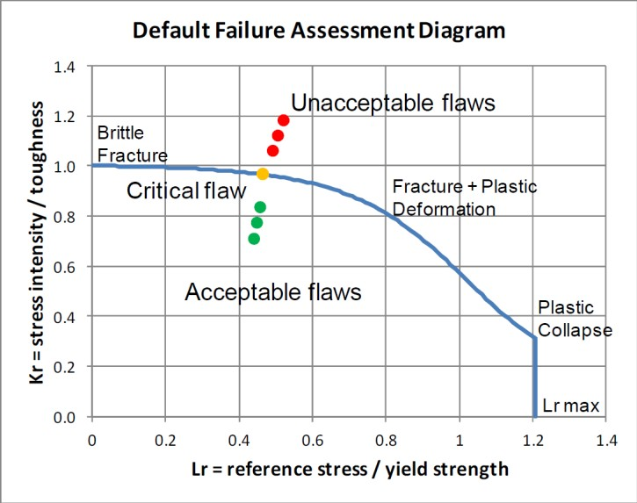

Fig. 5. Example of the default FAD and crack evaluation points [14]

When an analysis for a specific structural component and a stress-strain curve is available, a material specific FAD can be computed. The line equation for specifying acceptable and unacceptable flaws is presented below.

|  |  |
| --- | --- |
| 𝐾𝑟 = (1 − 0.14𝐿2)[0.3 + 0.7 exp(0.65𝐿5)]  𝑟 𝑟 | (12) |

Whereby,

|  |  |
| --- | --- |
| 𝜎𝑓𝑙𝑜𝑤 (𝜎𝑌 + 𝜎𝑈)/2  𝐿𝑟.𝑚𝑎𝑥 = 𝜎 = 𝜎  𝑌 𝑌 | (13) |
| 𝜎𝑟𝑒𝑓  𝐿𝑟 = 𝜎  𝑌 | (14) |

|  |  |
| --- | --- |
| 𝜎𝑟𝑒𝑓 = 𝐹𝜎𝑖 | (15) |
| 𝐾𝐼  𝐾𝑟 = 𝐾  𝐼𝐶 | (16) |

Where F is the geometry factor and 𝜎𝑖 is the load value at each load increment i. The FAD curve Lr values are computed at each load increment using the equation (15)

To obtain the tensile properties 𝜎𝑌. 𝜎𝑈, yield and ultimate stress, respectively and fracture toughness KIC data needed to apply FAD for the weld, tensile tests were performed using specimens from the spiral weldments of API X65-graded natural gas pipeline of diameter 1219mm and thickness 14.3mm [15]. Tables 1 lists the chemical composition of the base and the welding material. Table 2 shows the mechanical specifications regarding this modeled pipe. Moreover, stress strain curve of weld and the pipe has been compared in Fig. 6.

Table 1. Chemical Composition of API 5L X65 pipeline steel [15]

|  |  |  |  |  |  |  |  |
| --- | --- | --- | --- | --- | --- | --- | --- |
|  | Element | | | | | | |
| C | P | Mn | S | St | Fe | Ceq. |
| Chemical comp. | 0.08 | 0.019 | 1.45 | 0.003 | 0.31 | Balance | 0.32 |

Table 2. Tensile properties of natural gas pipeline [15]

|  |  |  |  |  |
| --- | --- | --- | --- | --- |
| Region | Yield strength (MPa) | Tensile strength (Mpa) | Elastic modulus (GPa) | KIC (MPam0.5) |
| Pipe | 488 | 631 | 210 | 300 |
| Spiral Weld | 530 | 678 | 210 | 268 |

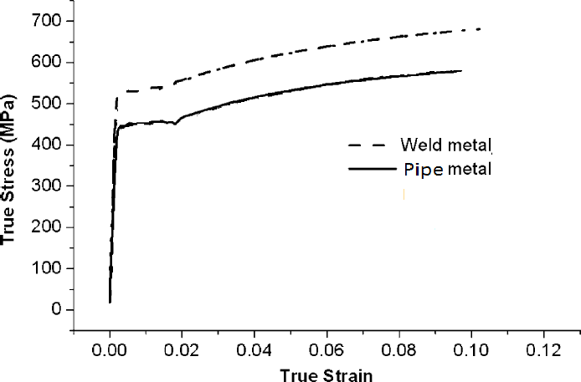

Fig. 6. Stress-Strain curve for pipe and weld material

To calculate stress intensity factor of crack in thin wall pipe with internal pressure load we have:

|  |  |
| --- | --- |
| KI = σ√πa F(λ)  a  λ =  √rt  F(λ) = {√(1 + 1.25 λ2) 0 < λ ≤ 1  0.6 + 0.9 λ 1 ≤ λ ≤ 5 | (17) |

Which a, P, r, t and KI are crack length, pressure, radius of pipe, wall thickness and stress intensity factor respectively. To obtain the stress values to gain the stress intensity factor, extended finite element has been done. Pipe and weld hoop stresses are calculated by FEM analysis which is elaborated. So, the presented model below Fig. 7 has been created to assess how the crack along the weld can affect the spiral pipe.

|  |  |
| --- | --- |
|  |  |

Fig. 7. Crack location and dimension on the spiral weld

The crack modeled in this analysis fig. 7 and its position on the pipe fig 11 are presented. The length and depth of crack were considered 250mm and 5mm, respectively. Cracked pipe is repaired by Clock Spring composite sleeve. Installation pressure assumed to be 1050 psi. one clock spring sleeve with length of 30 cm is installed on the crack area.

# Results

Generally, results showed an exponential reduction of stresses after installing the Clock Spring composite sleeves.

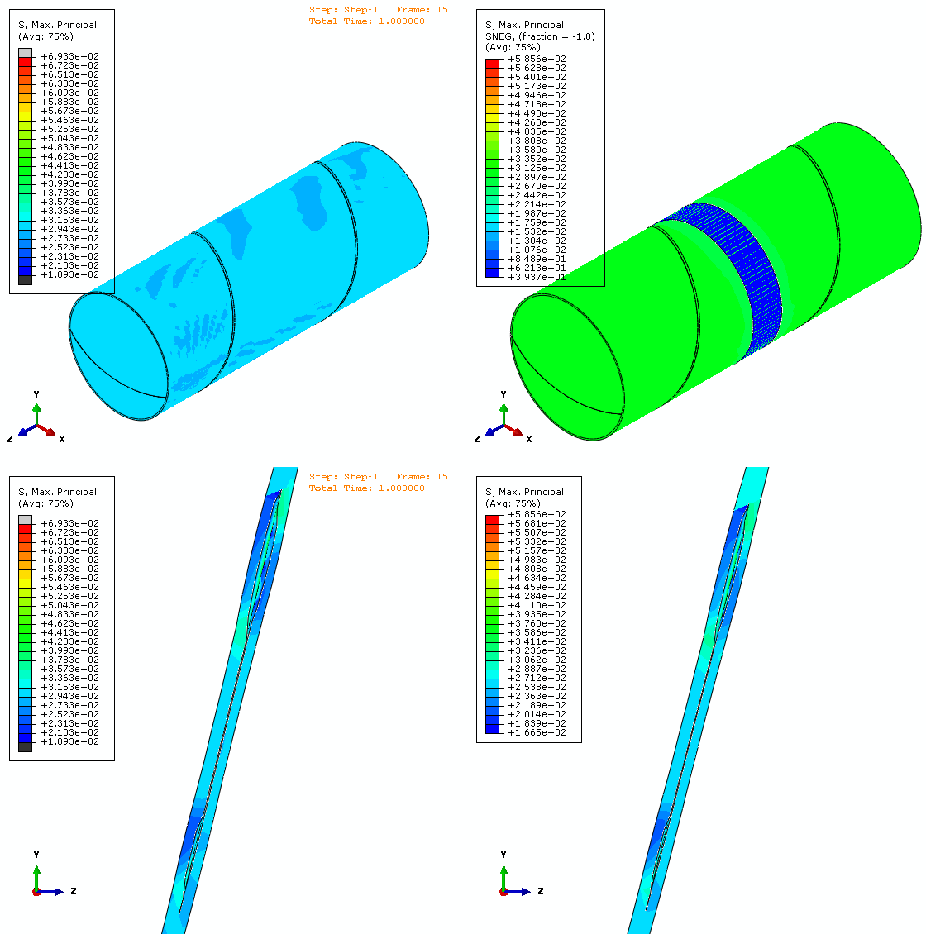

A- Damaged pipe B- Reinforced Pipe

Fig 8. Stress analysis comparison between cracked and repaired pipe

Fig. 8 reveals stresses values in both damaged and repaired pipe. It also shows crack propagations in the weld with deformation scale of 500. Obviously, reinforced by Clock Spring composite sleeve pipe has the lower values of stress. Maximum principal stress has been decreased from 693 MPa to 585 MPa.

In a more precise investigation, a series of analysis for various depth and length crack dimensions has been carried out to obtain data needed for FAD plots as well as to see how clock spring sleeve composite sleeve can lower stress intensities around cracked zones.

|  |  |  |  |
| --- | --- | --- | --- |
|  | 1 | 2 | 3 |
| A | C:\Users\Parsa\Desktop\crack\abaqus crack - plot\1- Damaged crack\6-load-vertical-depth-hor - Copy.tif | | |
| B |
| C |
|  | 1 | 2 | 3 |
| A | C:\Users\Parsa\Desktop\crack\abaqus crack - plot\1- Damaged crack\6-load-vertical-depth-hor2 - Copy.tif | | |
| B |
| C |

Fig 9. Maximum Principle Stress in damaged pipe

Fig 9 depicts maximum principle stresses of the damaged pipe in two views (whole pipe and crack region) with different crack’s dimensions. While in row A depth of initial crack increases from d=3mm in A1 to d=5mm in A2 and d=7mm in A3, in column 1 load pressure escalates from L=1MPa in A1 to L=2MPa in B1 and L=3MPa in C1. These numbers are true for other rows and columns. As it can be predicted, as crack’s depth increases, maximum principle stress surges too.

|  |  |  |  |
| --- | --- | --- | --- |
|  | 1 | 2 | 3 |
| A | C:\Users\Parsa\Desktop\crack\abaqus crack - plot\2- Reinforced composite sleeve\2.tif | | |
| B |
| C |
|  | 1 | 2 | 3 |
| A | C:\Users\Parsa\Desktop\crack\abaqus crack - plot\2- Reinforced composite sleeve\4.tif | | |
| B |
| C |

Fig 10. Maximum Principle Stress in reinforced pipe

Fig 10 reveals maximum principle stresses in the reinforced pipe by Clock Spring composite sleeve. As it can be foreseen, while crack’s depth growths, the stress progresses as well. Although installing Clock Spring sleeve can lower the stress in comparison with the damaged pipe. The effect of using composite sleeve is more perceptible when internal load pressure increases. For example, while in C1 the stress has been abridged nearly 1% from 97.78 MPa to 97.13 MPa, in C3 it has been reduced by 14% from 205MPa to 177MPa.

Kr

|  |  |  |  |  |  |  |  |
| --- | --- | --- | --- | --- | --- | --- | --- |
|  |  | FAD Di | agram |  |  | |  |
|  |  |  |  |  |  | |  |
| d= | 7mm |  |  |  |  | |  |
|  |  |  | d=5mm |  |  | |  |
|  |  |  |  |  |  |  |  |
|  |  |  | Lr | d=3mm |  |  |  |

Fig 11. Results of FAD for damaged and reinforced model in various crack’s depth

1.2

1

0.8

0.6

0.4

0.2

0

0

0.2

0.4

0.6

0.8

1

1.2

FFS assessment was performed for ﬂaws existing in pipeline welding using the tensile properties and fracture toughness values. Fig 11 shows FAD results of crack for variable depths for both damaged and repaired pipe. As it can be seen, for three different crack’s depth (d=3,5 and 7mm) while the length of crack is 250mm, analysis has been conducted. Noteworthy to note that green and red lines depict analysis in damaged and reinforced models, respectively. Obviously, as loading pressure increases, stress intensity factor surges dramatically, this is more noticeable when depth increases. Moreover, the effect of installing Clock Spring composite sleeve in reducing intensity factor is more visible when internal pressure rises and surely when crack’s depth growths. It should be noted that acceptable boundary points for these analysis can be interpolated for gaining failure fracture regions.

1.2

FAD Diagram

1

0.8

L=350mm

0.6

L=300mm

0.4

0.2

L=250mm

0

0

0.2

0.4

0.6

Lr

0.8

1

1.2

Kr

Fig 12. Results of FAD for damaged and reinforced model in various crack’s length

In another investigation the impact of initial crack’s length (L=250mm, 300mm and 350mm) before and after installing Clock Spring sleeve has been taken into consideration. Generally, in a specific loading condition pipes having higher crack’s lengths are exposed of rapid failure. Interesting to note that as this dimension increases, the reinforced model has the lower impact in controlling stress intensity values.

# Fatigue Crack Growth

Crack growth is computed using the Paris equation, using a coefficient and an exponent recommended for steel in a non-aggressive environment, of C = 8.61x10-19 and m=3.0, respectively (for stress intensity in MPa/mm and crack growth in mm/cycle).

𝑑𝑎 = 𝐶(Δ𝑘)𝑚

𝑑𝑁

The fatigue threshold stress intensity is assumed to be zero; therefore every cycle contributes to crack propagation. The internal pressure of the cycles starts from zero to the design pressure. An elastic finite element model is used to compute the crack stress intensity at the peak level of the cyclic load and at the operating pressure for each increment of crack growth.

Crack growth is modeled using a proper number of crack growth iterations to suitably converge on a solution. The initial sub-model included a rectangular crack of dimensions a=5mm (depth) and c=250mm (length). Using the stress intensity along the crack, the Paris equation is solved, at each iteration, for the number of cycles and the crack length for a specified incremental crack depth change. Starting at a depth of a=5mm, the incremental crack depth is increased by 0.1mm until the crack depth reached rapture.

According to the literature, once the crack depth reaches 80% of the total thickness, the crack can be recharacterized as a surface breaking crack. Once the crack depth reaches 11.44mm (or 80% of the total ligament thickness) during the fatigue crack growth, the resulting crack length must be known to recharacterize the crack. To recharacterize the crack, a second order polynomial interpolation was used to identify the number of cycles for the crack to reach 80% depth, which is around 1,000 cycles.

The FAD can then be evaluated, and the assessment point for the through-wall crack in the pipe can reflect the results of a through-wall crack under operating loads. Shown in Figure 13, the number of cycles in which rupture occurred for various crack depth has been considered in which crack length remains stable at L=250mm. The

blue line depicts the damaged model decreasing dramatically while the red line illustrates the reinforced by Clock Spring that controls the intensity of failure.

Crack Depth with Number of Cycles

16

14

12

10

8

6

4

2

0

0

1000

2000

3000

**Cycles**

4000

5000

6000

**Crack Depth, mm**

Fig 13. Crack depth with number of cycles

The number of cycles in which rupture happened for several crack length has been implemented can be seen in Fig. 14. In which both damaged and repaired model have the dwindling tendency towards cycle meaning as crack length declines, cycle’s number drops too. It should be noted that the initial depth for this plot has been considered d=5mm.

Crack Length with Number of Cycles

800

700

600

500

400

300

200

100

0

0

1000

2000

3000

**Cycles**

4000

5000

**Crack Length, mm**

Fig 14. Crack length with Number of Cycles

When the corner crack grows to a through-wall crack in the pipe, there would also be a through-wall crack formed in the pipe. It is perceived that the crack length was

growing faster than the crack depth, so it was anticipated that the crack length would be the larger crack dimension, and is likely to be the worst case.

# Concluding Remarks

The J integral is calculated along the crack of an inner crack at the junction between the welding and the spiral pipe. Using both elastic and elastic-plastic J integral results, crack stability is recognized using the FAD method using the brittle fracture ratio, Kr, and the plastic collapse ratio, Lr.

The crack’s dimensions are then calculated, resulting from cyclic fatigue loading, based on the Paris equation. The crack tended to propagate at a faster rate in the length direction than the depth direction. After propagation, the crack is then recharacterized as a through-wall crack, and evaluated using the FAD method. The through-wall crack is sufficiently large, that its assessment point lies above the FAD curve, and is a risk for sudden rupture. Finally, provided that the contents of the pipe leaking from the crack can be detected, and adequate detection instrumentation is operating, then the pipe will likely leak before rupture.

# References

1. Belytschko, Ted, Nicolas Moës, S. Usui, and C. Parimi. "Arbitrary discontinuities in finite elements." International Journal for Numerical Methods in Engineering 50, no. 4 (2001): 993-1013.
2. Dolbow, J. O. H. N., and Ted Belytschko. "A finite element method for crack growth without remeshing." International journal for numerical methods in engineering 46.1 (1999): 131-150.
3. Dolbow, John, Nicolas Moës, and Ted Belytschko. "Discontinuous enrichment in finite elements with a partition of unity method." Finite elements in analysis and design 36.3 (2000): 235-260.
4. Daux, Christophe, et al. "Arbitrary branched and intersecting cracks with the extended finite element method." International Journal for Numerical Methods in Engineering 48.12 (2000): 1741-1760.
5. Fries, Thomas‐Peter. "A corrected XFEM approximation without problems in blending elements." International Journal for Numerical Methods in Engineering 75.5 (2008): 503-532.
6. Irwin, George R. "Analysis of stresses and strains near the end of a crack traversing a plate." Journal of applied mechanics 24.3 (1957): 361-364.
7. Yau, J. F., S. S. Wang, and H. T. Corten. "A mixed-mode crack analysis of isotropic solids using conservation laws of elasticity." Journal of applied mechanics 47.2 (1980): 335-341.
8. Cherepanov, Genady P. "Crack propagation in continuous media: PMM vol. 31, no. 3, 1967, pp. 476–488." Journal of Applied Mathematics and Mechanics 31.3 (1967): 503-512.
9. Rice, James R. "A path independent integral and the approximate analysis of strain concentration by notches and cracks." ASME, 1968.
10. Kirchner, Helmut. "The force on an elastic singularity in a non-homogeneous medium." Journal of the Mechanics and Physics of Solids 47.4 (1999): 993-998.
11. Gurtin, Morton E. "The nature of configurational forces." Archive for Rational Mechanics and Analysis 131.1 (1995): 67-100.
12. Rabczuk, Timon, Stéphane Bordas, and Goangseup Zi. "On three-dimensional modelling of crack growth using partition of unity methods." Computers & structures 88.23 (2010): 1391-1411.
13. Wyart, Eric, et al. "Application of the substructured finite element/extended finite element method (S-FE/XFE) to the analysis of cracks in aircraft thin walled structures." Engineering Fracture Mechanics 76.1 (2009): 44-58.
14. Tipple, C., and G. Thorwald. "Using the Failure Assessment Diagram Method with Fatigue Crack Growth to Determine Leak-before-Rupture." 2012 SIMULIA Community Conference, Providence, Rhode Island. 2012.
15. Lee, Jung-Suk, et al. "Weld crack assessments in API X65 pipeline: failure assessment diagrams with variations in representative mechanical properties." Materials Science and Engineering: A 373.1 (2004): 122-130.